|  |  |  |
| --- | --- | --- |
| VILNIAUS KOLEGIJA  UNIVERSITY OF APPLIED SCIENCES  FACULTY OF ELECTRONICS AND INFORMATICS  https://screenshotscdn.firefoxusercontent.com/images/eaf3f7f3-2952-4801-af5c-4f20e8ae8b88.png | | |
|  | | |
| **LCD MONITOR PIXEL RESPONSE TIME MEASUREMENT** | | |
|  | | |
|  | | |
| LABORATORY WORK  6531BX028 PI18E | | |
| STUDENTS | (SIGNATURE) | EDITA KOMAROVA    EVALDAS PAULAUSKAS  DŽIUGAS PEČIULEVIČIUS |
| 2020-03 |
| (SIGNATURE) |
| 2020-03 |
| (SIGNATURE) |
| 2020-03 |
| (SIGNATURE) |
| LECTURER | 2020-03 | MARTYNAS ŠAPUROV | |

# OBJECTIVE

The objectives of this laboratory work are to understand the basic operation principles of liquid crystals display (LCD), measure the response time of the LCD with different display settings.

# Tr AND Tp OSCILLOGRAMS WITH DIFFERENT CONTRAST LEVELS

**1ST MONITOR**

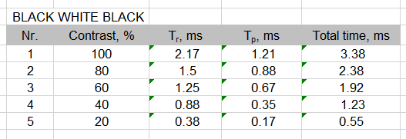

Figure 1 - 1st monitor black-white-black

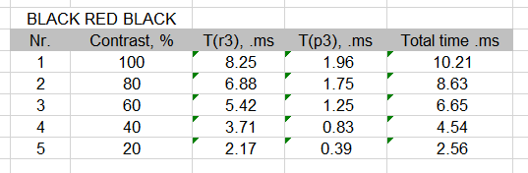

Figure 2 - 1st monitor black-red-black

**2ND MONITOR**

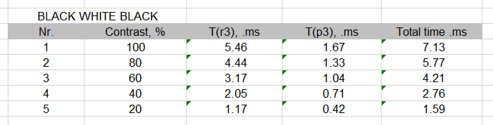

Figure 3 - 2nd monitor black-white-black

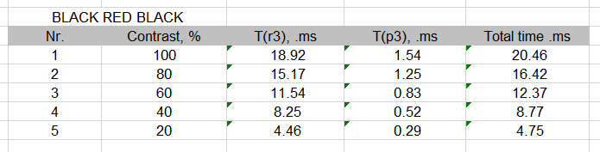

Figure 4 - 2nd monitor black-red-black

# RESPONSE TIME DEPENDENCE ON THE CONTRAST GRAPH FOR EACH MONITOR

**1ST MONITOR**

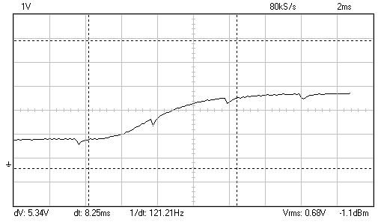

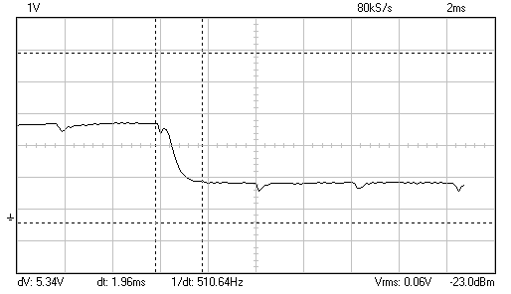

**2ND MONITOR**

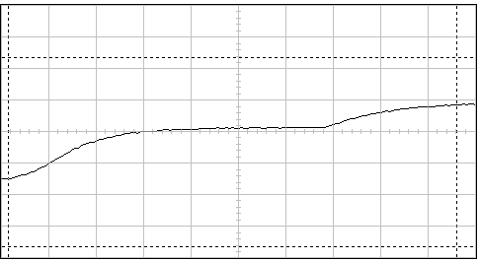

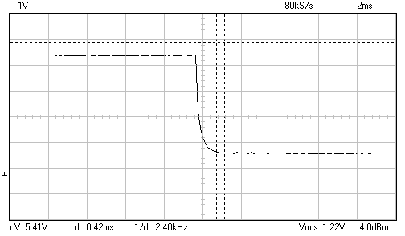

# GENERAL CONCLUSION

Colors changing from black to white is always going to be a faster transition than from white to black. Also transition from white to black and then back to white is always going to be faster than other colors. For example from black to red and then back to black. But measurments were done between 10% and 90% saturation. This is beacause it is not possible to accureately measure from 0% to 100%, since noise from the measurement equipment starts to interfere.

# ANSWERS TO REVIEW QUESTIONS AND TASKS

1. **Explain how the liquid crystal matrix works.**

A liquid-crystal display (LCD) is a flat-panel display or other electronically modulated optical device that uses the light-modulating properties of liquid crystals combined with polarizers. Liquid crystals do not emit light directly, instead using a backlight or reflector to produce images in color or monochrome.

1. **What is the difference between the TFT matrix and other liquid crystal technologies matrixes?**

Electric current inside the crystals is regulated by using thin film transistors (TFT). Such a light regulatory approach, when only the light strength level is constantly regulated is called active, while the matrix – the active matrix. However, this approach is not the only one. Passive matrix exists, it operates on the principle of light reflection. Here, in order to get a desired image, as opposed to active matrixes, the voltage is switched on. Such arrays are used, for example, in portable calculators.

1. **How a colour image is formed in the LCD display?**

In an LCD display instead of the electron flow, each point consists of three liquid crystal elements, or an array. Their combination provides the desired colour for one pixel.

1. **How a luminous image is formed in the LCD display?**

In a typical LCD monitor there is a cathode-ray tube installed at the back of the monitor, which gives lighting to the screen. Lately, instead of cathode ray tube, light-emitting diodes are used widely.

1. **What is the difference between LCD display matrix and liquid crystal matrixes in watches, calculators?**

In LCD display there are millions of crystal elements, for example, 1024×768 resolution display has – 1024 • 768 • 3 = 2359296crystal elements, including the fact that each element (pixel) consists of the 3-sub-elements (sub-pixel). Electric current inside thecrystals is regulated by using thin film transistors (TFT). Such a light regulatory approach, when only the light strength level is constantly regulated is called active, while the matrix – the active matrix. However, this approach is not the only one. Passive matrix exists, it operates on the principle of light reflection. Here, in order to get a desired image, as opposed to active matrixes, the voltage is switched on. Such arrays are used, for example, in portable calculators.

1. **Explain the meaning of the response time parameter.**

The parameter that evaluates the monitor’s lag is called the response time. Traditionally, the monitor’s response time is measured as the total switching time between the white and black colors and back, including the fact that the measurements are carried out between 10 % and 90 % saturation. The response time measurement device consists of a photo diode VD1, which captures the brightness on the surface of the tested screen. Current is transformed to a voltage reference by using an operational amplifier.

1. **Explain the response time measurement method.**

To measure the response time for this work, we need few programs and a oscilloscope to measure the response time. We firstly turn on LCDTest program to run the flickering test, then we use Pc_Lab-2000se program to measure the response time with the device.

1. **Is the response time dependent on the color it switches from? If yes, please explain briefly.**

Yes, the response time is dependent on the color it switches from. Basically it switches faster from white to black, and from black to white.

1. **Calculate the liquid crystal elements (pixel and sub-pixel) in a 1024 × 600 resolution matrix.**

In LCD display there are millions of crystal elements, for example, 1024×768 resolution display has – 1024 • 768 • 3 = 2359296 crystal elements, including the fact that each element (pixel) consists of the 3-sub-elements (sub-pixel)

1. **What response time LCD monitor manufacturers usually state in the specification?**

Usually the best results are obtained when the point transitions from white to black. Manufacturers of LCD monitors usually state this result for the specification. If a different measurement would be made, for example, point transition from red to black, the result would be a completely different number, far from the one stated in the specification.